McNeil High School Wrestling T-Shirt Form
Order your 2016 McNeil Wrestling t-shirt now! T-shirts are gray with navy letters on front and back. T-shirt is $10.00 for McNeil students. Cost is $15.00 for anyone other than a McNeil student. Pickups will be through Coach Steele.
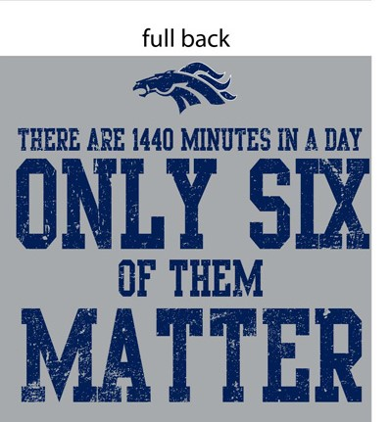

Quantity | Small | Medium | Large | X-Large | 2 X-Large | 3 X-Large | Total Due (students)  (# X $10.00) | Total Due (Others)  (# X $15.00)

Please complete this form and return to Coach Steele or mail to McNeil HS Wrestling Booster Club at 5720 McNeil Dr. Austin, TX 78729. If you have any questions email Carolyn Kyzar at ckyzar@gmail.com.
Name: _____________________________________________________________
Phone: ____________________ Email: ___________________________________
❏ Cash ❏ Check (payable to MHS Wrestling Booster Club, DL # )
Total Due (# X $10.00; others $15.00): $___________

THANKS!!

